Reinforcement Learning Based Stabilization of Liquid Surface in Ground Vehicle payloads

Kshitij Bithel, Keshav Dixit, Dr. Sohom Chakrabarty

# 

**Abstract** — Sloshing refers to the motion of the free liquid surface inside its container. It is a complex nonlinear dynamical phenomenon which has a significant influence on the stability of the fluid system. It affects various engineering systems and processes such as liquid storage tanks, liquid rocket fuel tanks, molten metal handling in steel plants, robotic handling of liquids, etc. We aim to solve the problem of minimizing slosh in Automated Ground Vehicle (AGV) payloads, i.e., stabilize the free surface of a liquid inside a container placed as payload on an AGV, while the AGV traverses along specified paths in a 2-D plane. For this purpose, a Deep Reinforcement Learning (DRL) framework will be designed to deliver the control input to a prototype AGV to move it to a destination point along desired 2-D paths while minimizing the slosh of the payload liquid as well as minimizing the time taken to reach the destination.

1. **Introduction**

Sloshing is commonly defined as the movement of a free liquid surface within its container. During the translational or rotational accelerations of the liquid containers, a substantial volume of liquid tends to move unrestrained in the containers, generating the sloshing problem which has a significant negative impact on the performance of industrial processes and is hard to eradicate. Hence, it is essential to analyze and precisely characterize the sloshing phenomenon, as well as to establish, identify, and experimentally evaluate mathematical models of slosh that may be employed to control development.

A nonlinear and complicated mathematical model can be utilized to represent the sloshing dynamics**[2]** but such dynamics are too challenging for the controller design. To represent the sloshing phenomenon, spring-mass damper and pendulum models are commonly used.

Passive control techniques like baffles**[1][3]** have been used to control slosh for a long time. However, it increases the system's weight and, as a result, the cost, making it less desirable. Researchers have been increasingly interested in active control solutions for slosh suppression over the last two decades**[4][5][6]** .

The report is organized as follows. In Section 2, the major objectives are listed. In section 3, slosh measurement technique is described. In section 4, implemented control techniques are discussed. In section 5, future work is described, followed by References.

# **Objectives**

1. **Completed**

* To build a hardware prototype capable of measuring linear slosh in liquid payload and navigate in a 2-D workspace.
* Implement Trajectory control and Velocity Control on the AGV

1. **To be done**

* To deploy the Deep RL model and minimize both the time taken, and linear slosh produced in the liquid payload while navigating from one point to other in a 2-D workspace

# **Slosh Measurement**

We are currently using Capacitive sensors for slosh measurement. We also tested with ultrasonic sensor and ToF sensor, but the observed readings were noisy and inaccurate. Raw capacitance readings had a drifting characteristic and were very susceptible to external interference. So, to shield the capacitors we used Kapton Tape for ESD protection (Fig2 a) and covered it with an Aluminum sheet connected to SHLD pin of FDC1004 sensor for protection from Electro-Magnetic Interference (Fig2b)

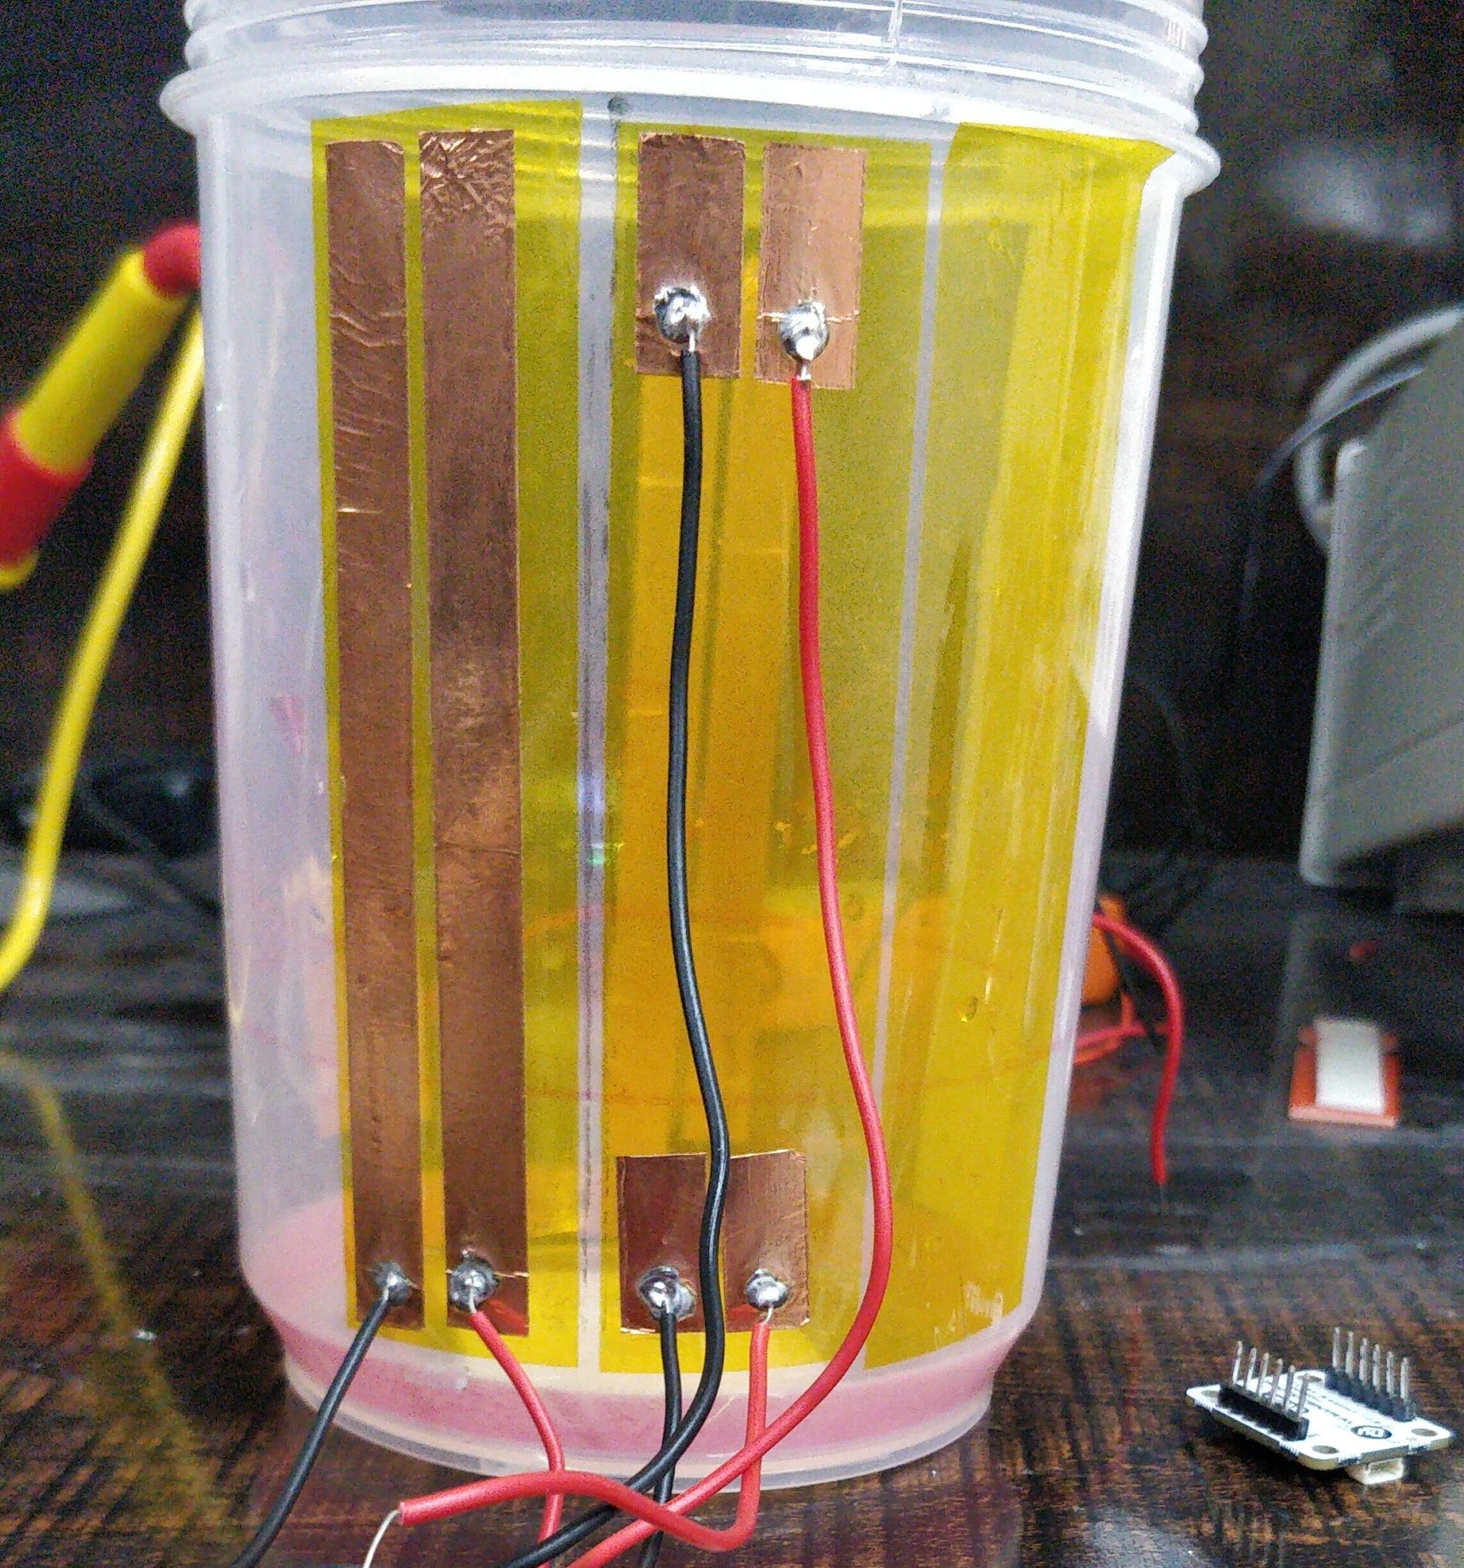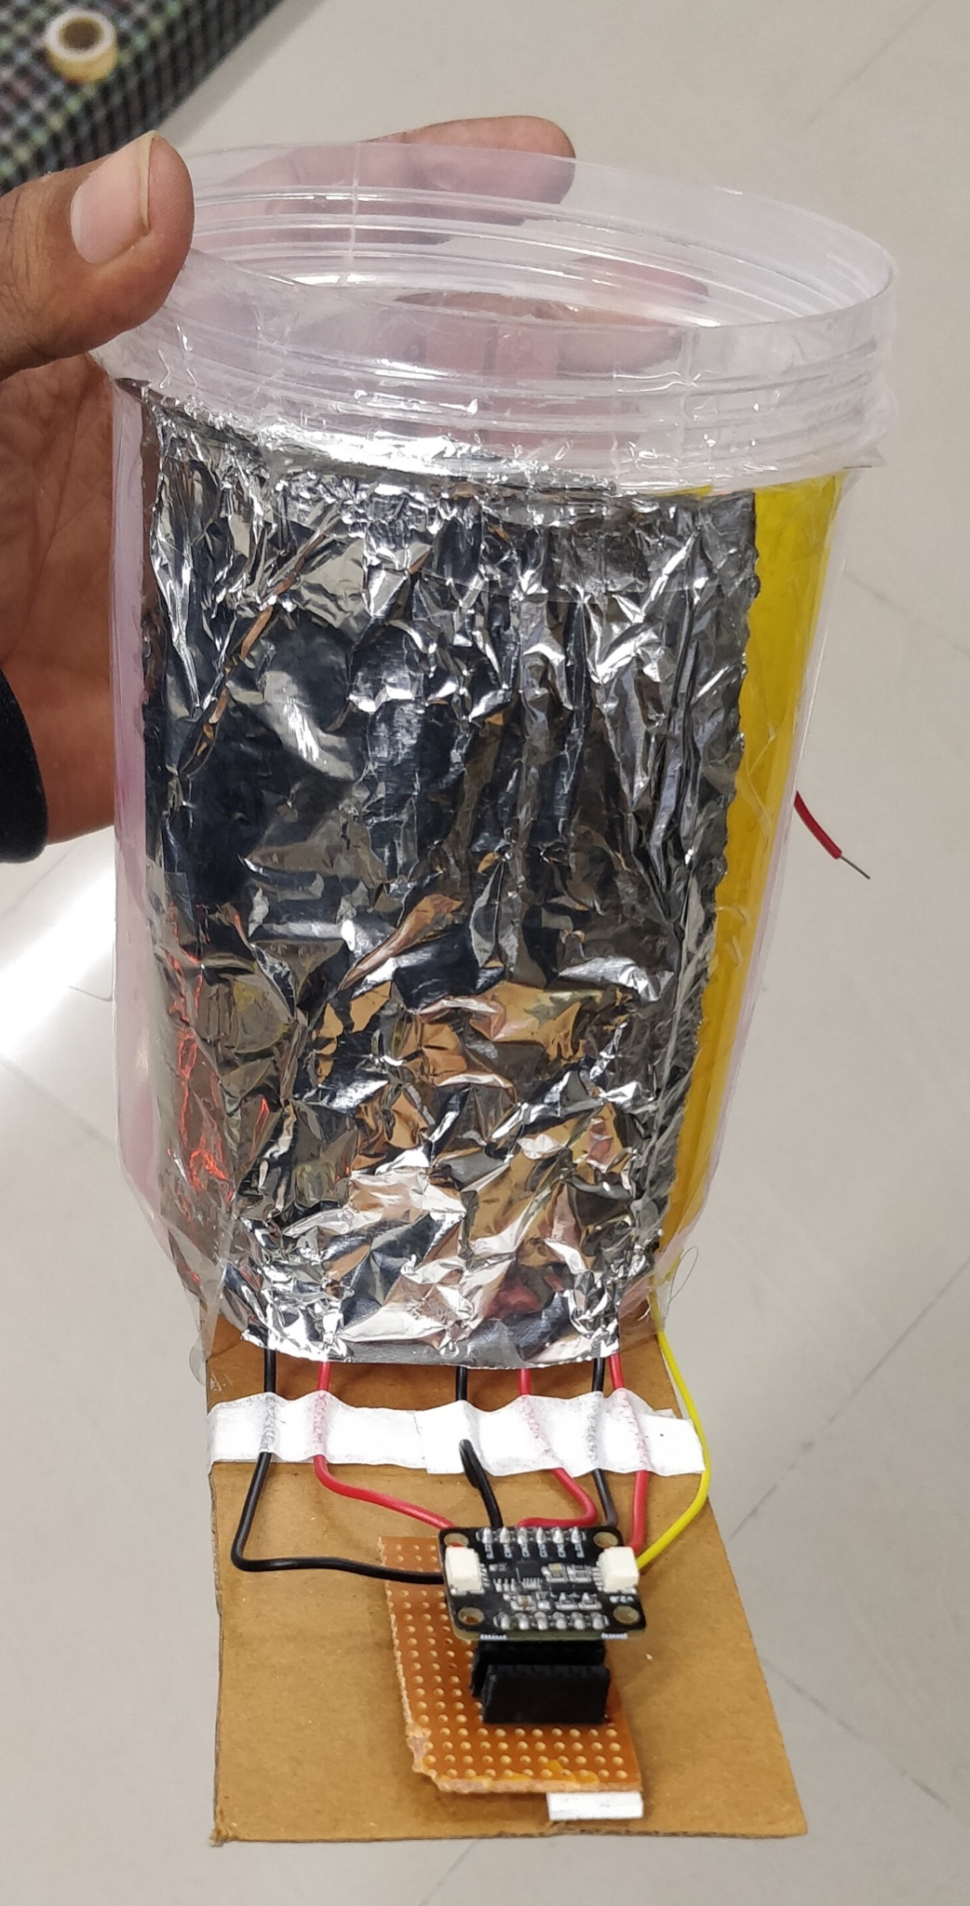

Fig2. a) ESD shielding using Kapton Tape b) EMI Shielding using Aluminum Sheet

# **Control Techniques**

Presently, we have focused on the 1-D motion of the AGV i.e. moving it back and forth in a straight line. For this, we have implemented orientation control with yaw angle feedback from the IMU and path tracking and velocity control with position, velocity feedback from LIDAR sensors. Currently we are using PID Controller for orientation control and path tracking and Fuzzy Controller for Velocity Control(Fig 3). The following control techniques were tested

1. **PID Controller**

The Proportional-Integral-Derivative (PID) controller was used according to the equation

*Output = Kp*(Desired Value - Current Value) +   
 Kd*(Current_error - Previous_error) +  
 Ki*(Accumulated_Error)*

1. **Fuzzy Controller**

The Fuzzy Controller has been used to carry out velocity control using velocity values from LIDAR. For fuzzification triangular membership functions have been used and Defuzzification is done by finding the centroid.

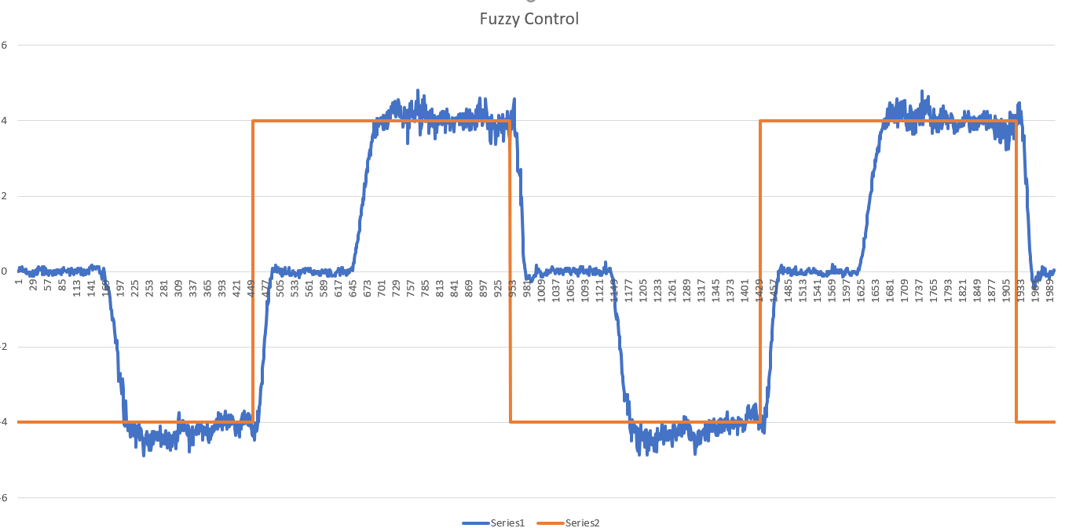

Fig3. Desired Velocity (orange) and Actual Velocity (blue)

1. **Adaptive PID**

The Adaptive Proportional-Integral-Derivative (PID) controller was used according to the equations  
*Output = Kp*(Desired Value - Current Value) +   
 Kd*(Current_error - Previous_error) +  
 Ki*(Accumulated_Error)*

*Kp’ = - Ɣ * (Current_error) * (Current_error)*

*Kd’ = - Ɣ * (Current_error) * (d_Current_error)*

*Ki’ = - Ɣ * (Current_error) * (Accumulated_error)*

Where *Ɣ is the Adaptation Coefficient and* ***f’*** *is the first derivative of f****[7]*** *.*

# **Future Work**

We aim to make this fully Autonomous. An RL framework will be designed with the aim to generate control inputs for navigation of an AGV in desired 2-D paths while minimizing the slosh in the payload liquid. For this RL model, a suitable reward signal needs to be designed and the obtained state information needs to be used from the system and its surroundings. The RL model will then be deployed to our prototype AGV hardware where its outputs will be used to decide the instantaneous velocity of the AGV.

# **References**

[1] H. N. Abramson, “The dynamic behavior of liquids in moving containers with applications to space vehicle technology”, *NASA Tech Rep.* ,1966.

[2]L. D. Peterson, E. F. Crawley, and R. J. Hansman, “Nonlinear fluid slosh coupled to the dynamics of a spacecraft,” *AIAA Journal*, vol. 27, Sep. 1989.

[3]R. A. Ibrahim, V. N. Pilipchuk, and T. Ikeda, “Recent Advances in Liquid Sloshing Dynamics,” *Applied Mechanics Reviews*,Mar. 2001.

[4]K. Terashima and K. Yano, “Sloshing analysis and suppression control of tilting-type automatic pouring machine,” *Control Engineering Practice*, Jun. 2001.

[5]P. S. Gandhi and A. Duggal, “Active stabilization of lateral and rotary slosh in cylindrical tanks,” Feb. 2009.

[6]B. Bandyopadhyay, P. S. Gandhi, and S. Kurode, “Sliding Mode Observer Based Sliding Mode Controller for Slosh-Free Motion Through PID Scheme,” *IEEE Transactions on Industrial Electronics*, Sep. 2009.

[7]Feng Lin, R. D. Brandt, and G. Saikalis, “Self-tuning of PID controllers by adaptive interaction,” 2000.